CURRICULUM VITAE
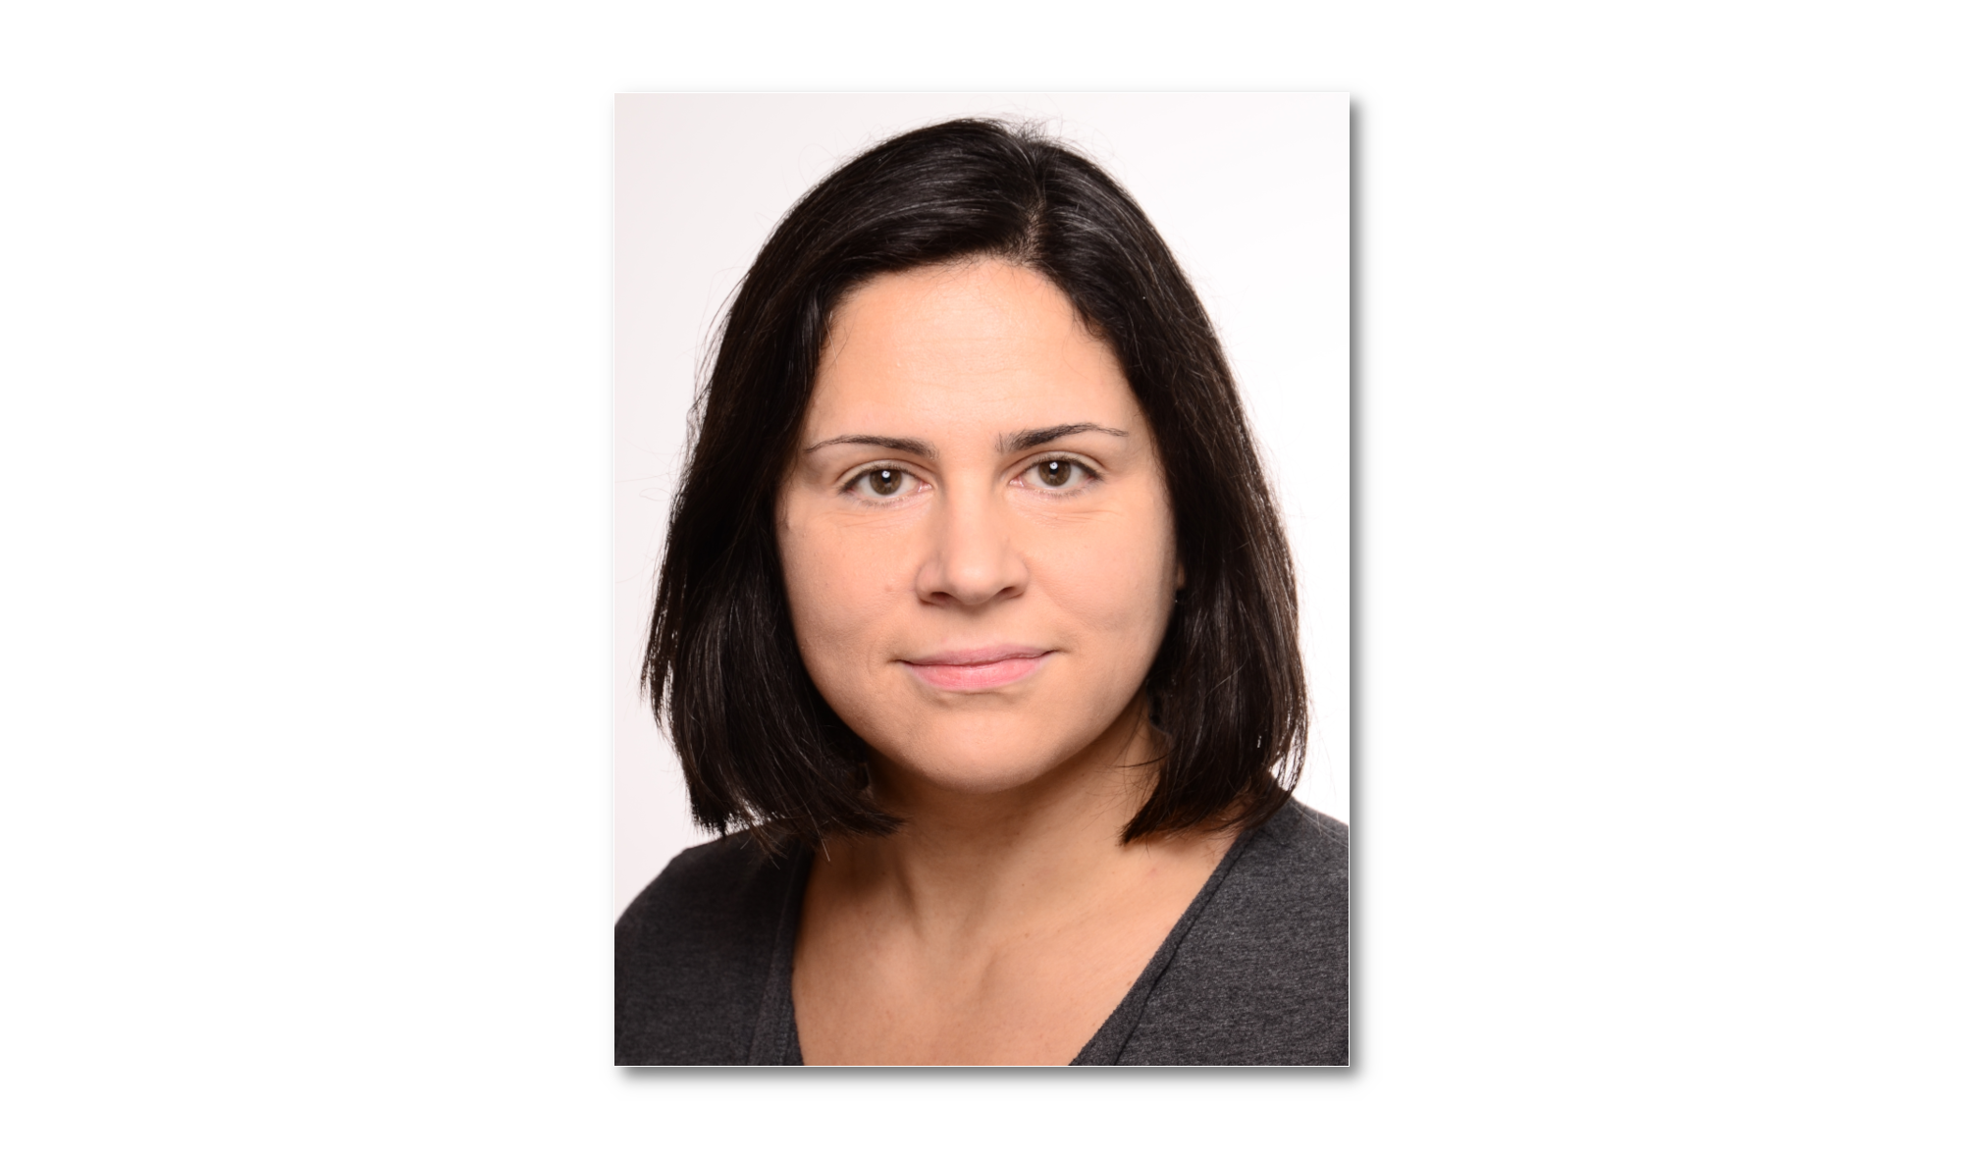
ANDREA VARGA

SENIOR SOFTWARE ENGINEER
Passionate about programming and software development.
My goal is to collaborate in a professional team, create useful applications,
learn a lot and have fun in the process.

+49 171 2248040
andrea@narancs.net
Website: andrea.narancs.net
Date of birth: 12. March 1978
Place of birth: Oradea (Romania)
Living in: Teltow (Berlin area), Germany

PROFESSIONAL EXPERIENCE
12.2018 – present  Responsibilities: | NTT Germany AG & Co. KG (Berlin, Germany) - Global IT services provider (~3000 employees in Germany, >300000 employees worldwide)  Senior Software Developer  - Design and development of several internally used, mostly web based applications with main focus on security and effectiveness. Main technologies: PHP, MySQL, JavaScript  - Optimization, modernization and further development of legacy software  - Improvement of development processes (CI/CD in GitLab and GitHub)
10.2009 – 11.2018  Responsibilities: | HMP Change GmbH / FIT Talent Management GmbH (Berlin, Germany) - Human Resources Consultancy specialised for Talent and Transformation management (~25 employees)  Senior Software Developer, Team Lead  - Implementation of several Performance and Talent Management solutions, being involved in the full life cycle of the application development, from software and database design, coding and testing to deployment and maintenance of the systems. Main technologies: PHP, MySQL, Adobe Flex and Flash (ActionScript and MXML)  - Leading a small group of developers  - Investigating new technologies, consulting colleagues and presenting ideas for system improvements
09.2001 – 09.2009  Responsibilities: | Virtualro SRL / Spin Development SRL (Cluj-Napoca, Romania) - Software development company focusing on e-commerce solutions (8-10 employees)  Senior Web Developer, Team Lead  - Design, development and testing of various web applications, online stores and content management systems. Technologies: Adobe Flex and Flash, PHP, MySQL, HTML, JavaScript, CSS  - Leading a small group of developers and designers  - Interacting with clients  - Training new employees
1990 - 2001  Responsibilities: | Resource Center of Ethnocultural Diversity (Cluj-Napoca, Romania)  Web Developer (Project based)  - Maintenance and extension of the online version of the Provincia newspaper (technologies: Perl, C, HTML, JavaScript)  - Design and implementation of a web-based content management systems for various RCED databases
Portfolio: https://andrea.narancs.net/portfolio.php
EDUCATION
1996 – 2001 | Engineer in Computer Science – Technical University Cluj-Napoca, Faculty of Automation and Computer Science, major Computer Science
1992 – 1996 | Junior Analyst Programmer – Ady Endre High School, Oradea

LANGUAGES
English – fluent German – fluent
Hungarian – native Romanian – fluent

TECHNICAL SKILLS & CERTIFICATIONS
Programming Languages:
Over 20 years of experience with: PHP, JavaScript, Flash and Flex (ActionScript 3, MXML)
- Other languages I used: C# (.NET), Python, Java, VBA, C/C++
Technologies:
Many years of experience in both frontend and backend web development, OOP, API development, experience with several frameworks (e.g. Slim PHP, Vue.js, Adobe Flex Frameworks)
Experience with Unix based servers and system monitoring
Many more (e.g. MQTT over websockets, ServiceNow API, user interface design)
Others:
I have a passion for writing clean and maintainable code, complying with coding standards and naming conventions, attention to details
- I am comfortable with agile development, especially continuous integration and frequent delivery
I am collaborative, eager to learn and happy to share my knowledge
Certifications | - Microsoft Azure Fundamentals - AZ-900 (2023)  Macromedia Flash MX 2004 Developer (2005)

Volunteering
summer 2018 | Mentoring Python learners for 1 Million Women To Tech, non-profit organisation with the goal to provide science education to women (online)
2007 – 2010 | Teaching step and dance aerobics classes from beginner to advanced, several times a week by Anita Health Center (Cluj-Napoca, Romania)
1999 – 2001 | Web Developer tasks like maintenance and extension of the web software (technologies: Perl, HTML, JavaScript, C) for Transindex , a non-profit foundation issuing a hungarian on-line newspaper published in Romania

